# Automatic weapons

Expert on the ethics of war and laws of letal automatonus weapons. Based in Berlin

Nathan G. Wood

## Autonomous Weapons System and Resonsibility for War Crimes

The law of Armed Conflict (LOAC)

The principle of Distinction

Autonomous Weapons System

* simple(r) AWS
* Unpredictable AWS

Conclusion

Is a body of law, not necessary binding for every state. The principle of distnction one possibility of a system than might make a mistake

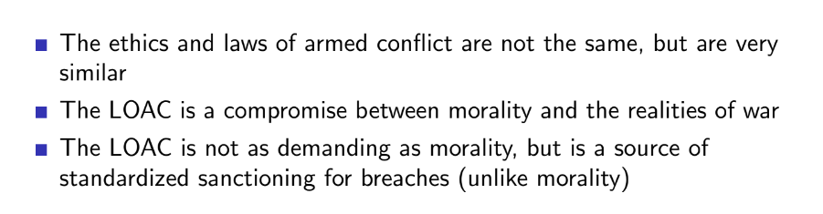

war is a morally weighted enterprise. The law of war needs to track moral concern. Generally treat all parts equally.

LOAC compromise between reality and morality. War is messy and difficult business, LOAC good to agree to, meant to be that does not advatages to no one. Standardized sanctioning for breaches

Requires proof to sanctions.

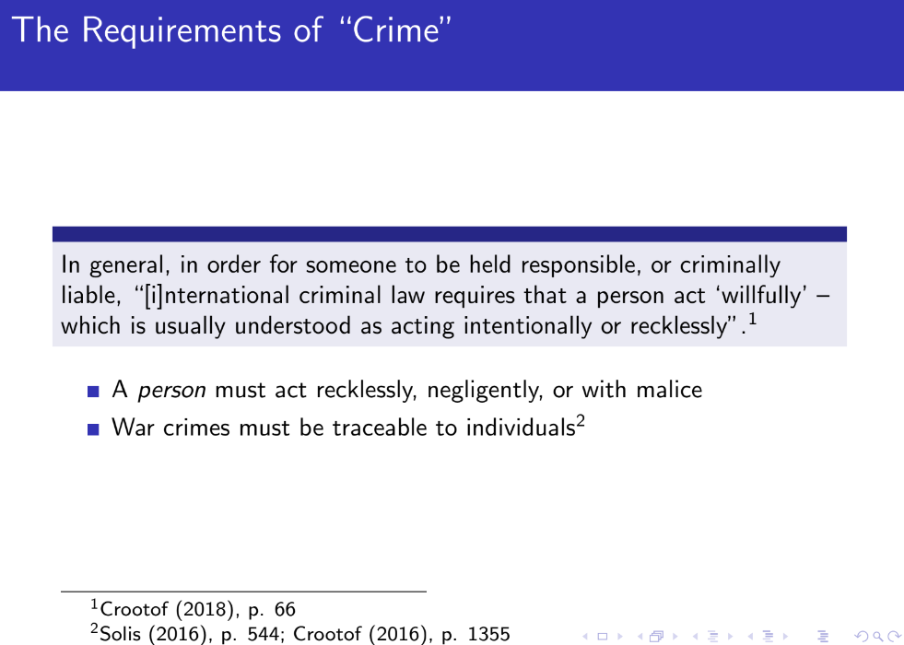

war crime = person act recklessly, negligently or with malice

International criminal law makes people traceable. Automatics are difficult to track it back to someone who have done it.

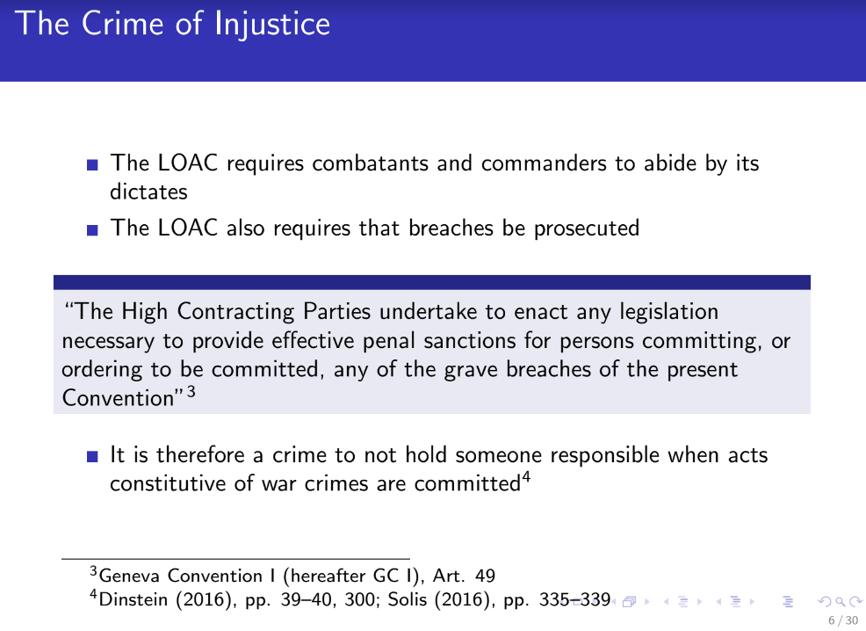

Double dows. Also requires to enforce the law to avoid someone getting away with something illegal.

If commander ask soldier to commint war crime they are responsable to have done it, if the commander is not trial we can find someone that **“helped” him to avoid the trial**. Can be trace. if someone does this then is **obstruction of justice**.

Automonus weapons: can’t tell who is respnsbile at the end of the chain we are stopped at the investigation.

**Is a crmine to not hold someone responsable when a war crime is commited.**

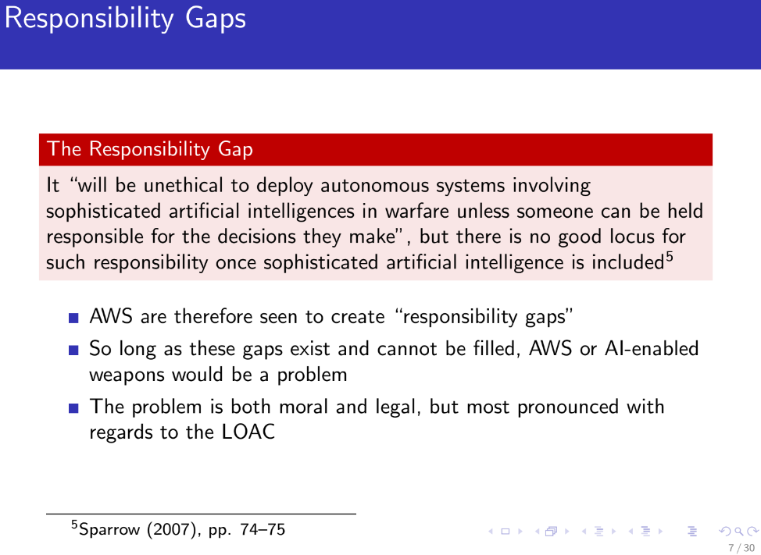

**Responsability gap**: need to have someone responsable for the involving use of artificial intelligence in warfare. Until those gaps are filled AWS (Autonomus Weapons System) and AI-enable weapons would be a problem

Is possible you might not know why they did what they did, so long as this gaps exist we will still have gaps.

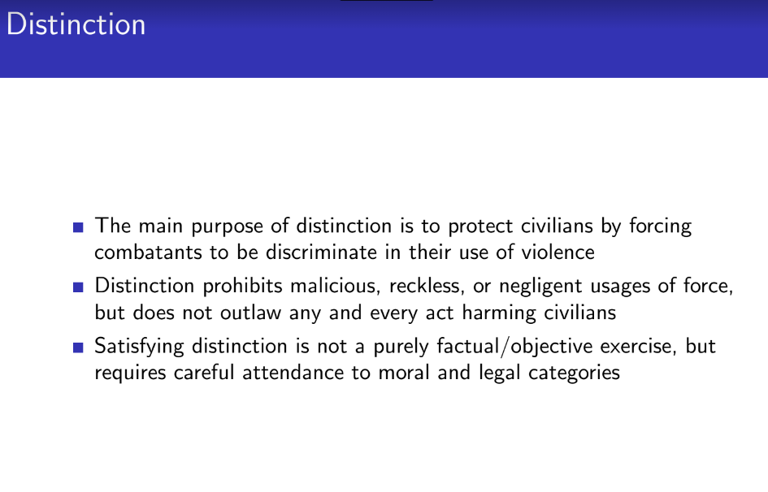

**Distinction: is about** targeting, all kinds of things that go wrong. it does not prohibits things go wrong but thighs to go negligent.

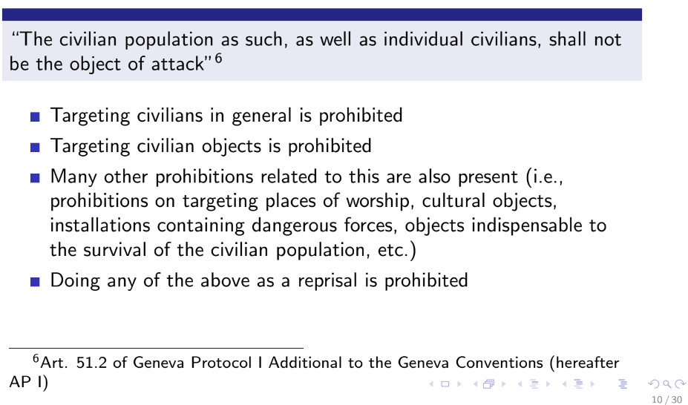

if you did it you go to jail

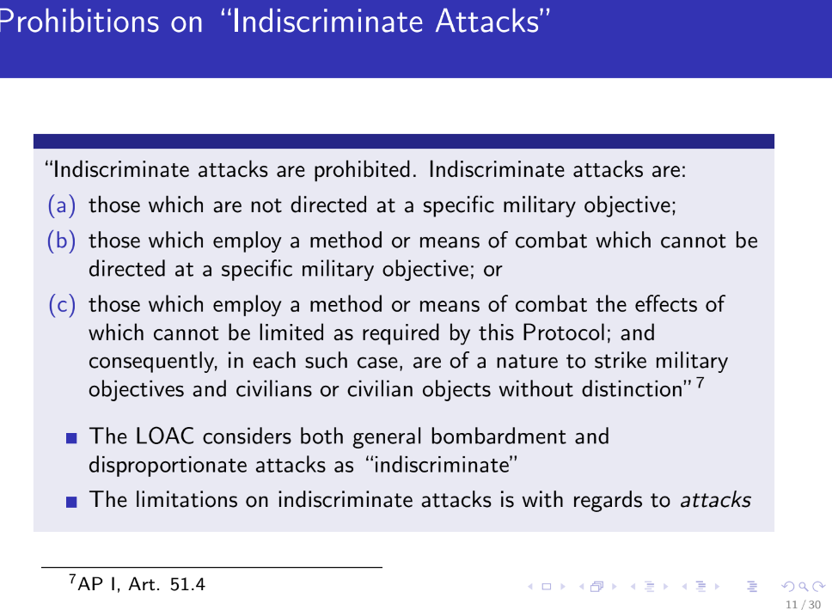

you can not target civilians, need to be sure to attack only attackers.

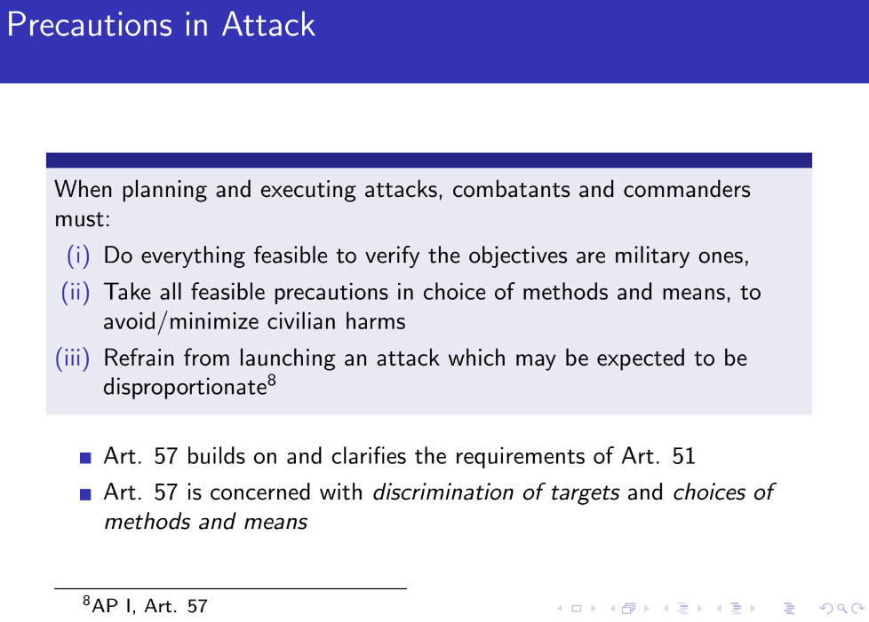

companies can't investigate all states that bout their product

Autonomous system do one thing that looks like a war crime because civilian where targeted. Not sure who was responsable.

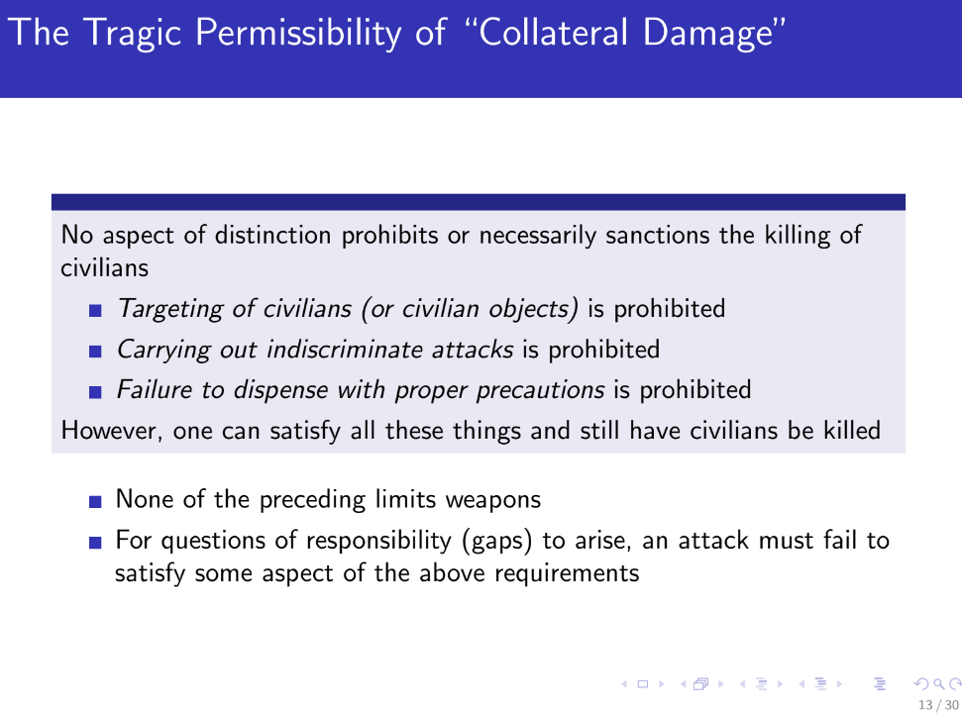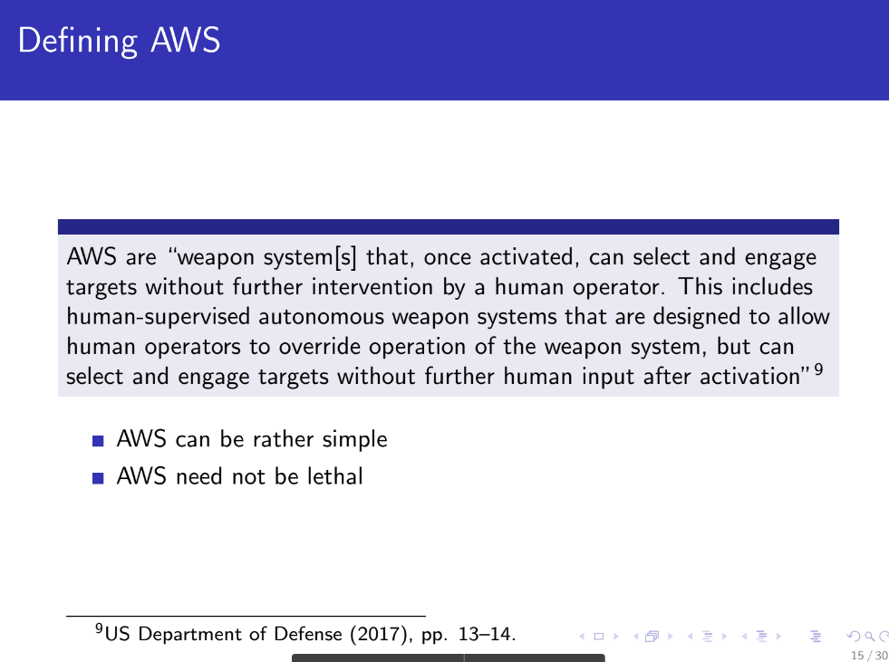

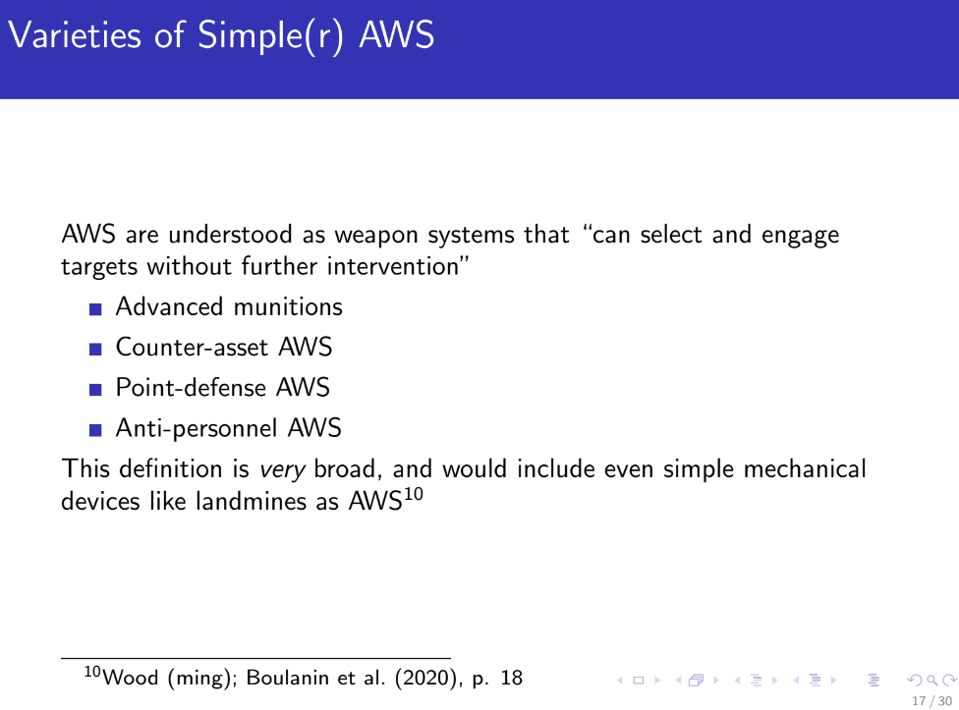

The type of autonomous system affect the responsibility

By looking at individual system it will be clear that making overall judgements is stupid, it will be wrong in most cases

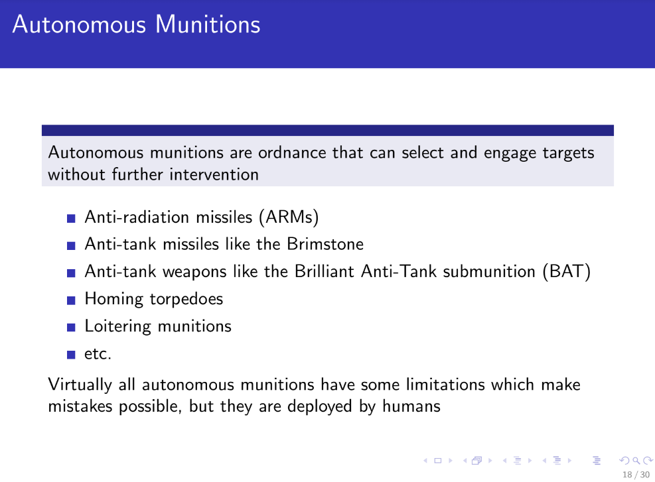

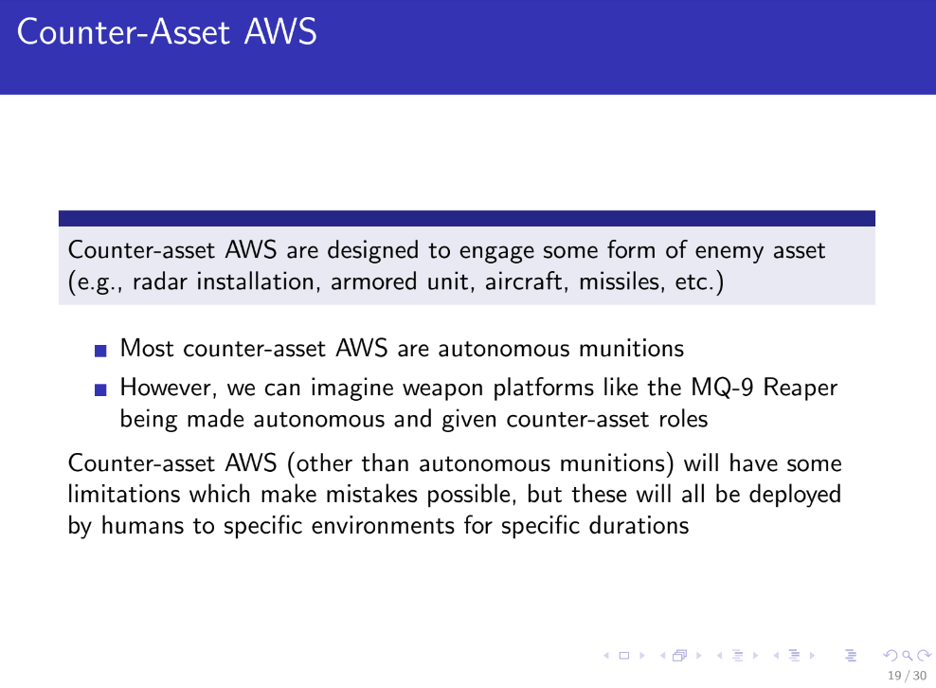

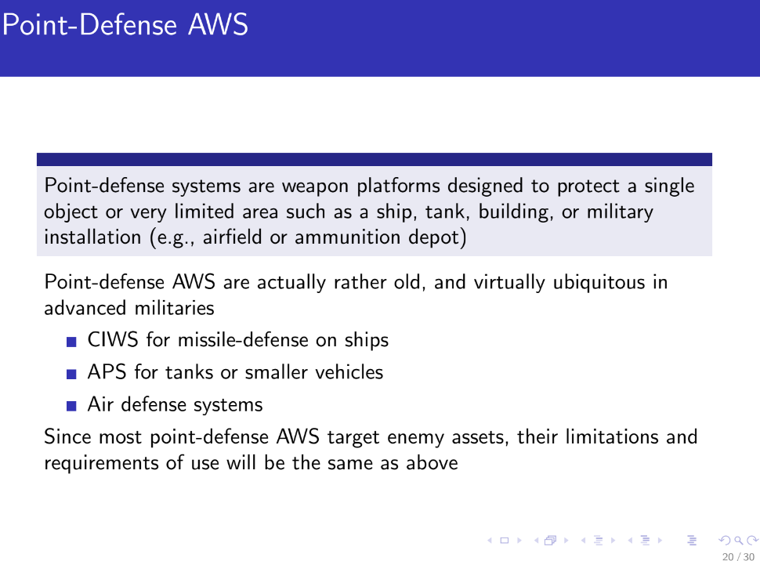

Protect single obejct (ship,…) need a robot. Shooting down missle, not civilians. Not a problem,

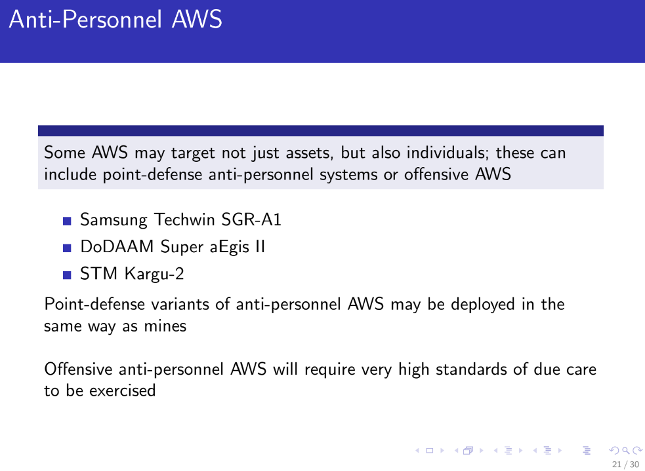

Can not identity soldier-civilians

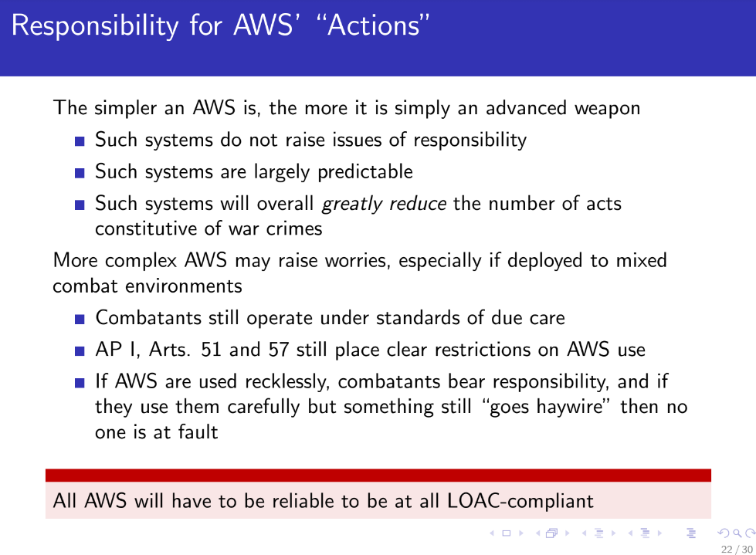

When they engage in war crimes are they more efficient?

Machine are really fast and efficient, can do things really well. More importance of the context than the system. Better simple autonomous weapons compared to more difficult (they are unpredictable).

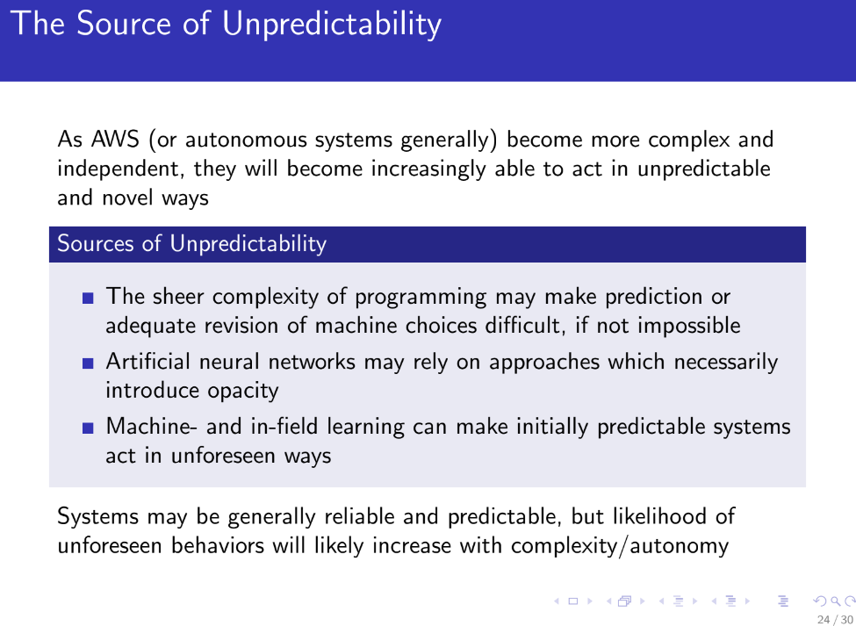

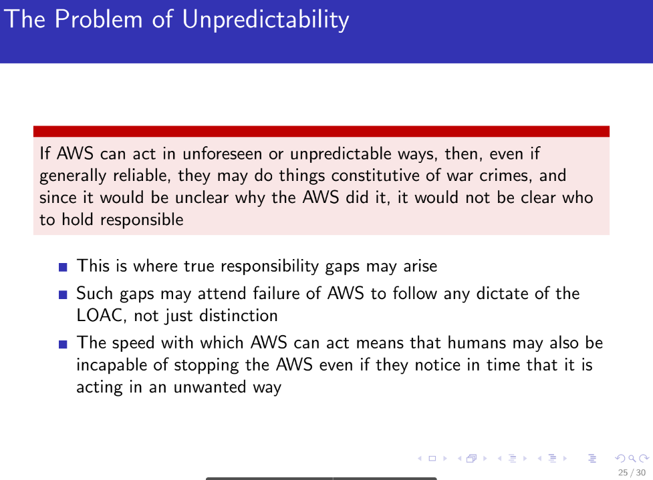

That is the real problem (unpredicted weapons can make war crimes).

